University of Petroleum and Energy Studies

Internship - High Level Design

on

Autonomous AI Customer Support Agent Voice & Chat

Team members:
Suraj Kumar – 590016150
Lucky Patel - 590016745
Abhishek Kumar - 590018880

Guided by: Dr. SURESH VEESA

Industry Mentor: Ms. POOJA SINGH

Table of Contents

- Introduction............................................................................................................................... 6
  - Scope of the document............................................................................................................................. 6
  - Intended Audience................................................................................................................................... 6
  - System overview...................................................................................................................................... 6

- System Design............................................................................................................................ 6
  - Application Design................................................................................................................................. 6
  - Process Flow........................................................................................................................................... 6
  - Information Flow.................................................................................................................................... 7
  - Components Design................................................................................................................................ 8
  - Key Design Considerations…................................................................................................................. 8
  - API Catalogue.......................................................................................................................................... 8

- Data Design............................................................................................................................... 8
  - Data Model............................................................................................................................................. 8
  - Data Access Mechanism......................................................................................................................... 9
  - Data Retention Policies.......................................................................................................................... 9
  - Data Migration........................................................................................................................................ 9

- Interfaces………………………………….……………………………………………………9

- State and Session Management.................................................................................................10

- Caching……………………………………………………………………………………….10

- Non-Functional Requirements…….........................................................................................10
  - Security Aspects.................................................................................................................................10
  - Performance Aspects.........................................................................................................................10

- References.................................................................................................................................11

- Introduction
The rapid growth of digital platforms has transformed how businesses interact with customers. In modern e-commerce systems, providing efficient and real-time customer support is a critical requirement. Traditional customer support systems, which rely on human agents, often face challenges such as delayed response time, high operational costs, and limited scalability.
To address these challenges, Artificial Intelligence (AI) based solutions have been introduced. AI-powered chatbots and virtual assistants can handle customer queries automatically, providing fast and accurate responses without human intervention.
This project presents the design and development of an AI-based Customer Support System for an Online Bookstore. The system enables users to interact with the platform using both text and voice inputs. It leverages Natural Language Processing (NLP) and speech processing technologies to understand user queries and generate appropriate responses.
1.1 Scope of the Document
This document provides a high-level design (HLD) of the proposed system. It describes the overall architecture, system components, and their interactions.
The scope of this document includes:
- Overview of the AI-based customer support system
- Description of key components such as frontend, backend, database, and AI module
- Explanation of chatbot and voice interaction features
- High-level data flow within the system
- Technologies used for system implementation
This document does not include low-level design details such as code implementation, algorithms, or database schema.
1.2 Intended Audience
This document is intended for various stakeholders involved in the development and evaluation of the system, including:
- Developers – To understand system architecture and component interactions
- Project Evaluators / Faculty – To assess the design and approach
- System Architects – To review scalability and design decisions
- Test Engineers – To understand system workflow for testing
- End Users / Stakeholders – To get an overview of system functionality

1.3 System Overview
The proposed system is a web-based online bookstore integrated with an AI-powered customer support agent. It allows users to browse books, search for specific titles or authors, and interact with the system through an intelligent chatbot.
The chatbot is capable of handling user queries in real-time using Natural Language Processing (NLP). It can answer questions related to books, pricing, availability, and general assistance. The system also supports voice interaction, where user speech is converted into text, processed by the AI module, and the response can be delivered in both text and voice format.
System Components:
- Frontend (User Interface)
- Developed using React
- Provides book browsing, search, and chatbot interface
- Backend (Server - Flask)
- Handles API requests
- Processes user queries
- Communicates with AI module
- Database (MongoDB)
- Stores book details (ISBN, title, author, etc.)
- Stores user data and interactions
- AI Module (NLP Engine)
- Understands user queries
- Identifies user intent
- Generates responses
- Speech Processing Module
- Converts speech to text (input)
- Converts text to speech (output)
Working of the System (High-Level Flow):
- User enters a query (text or voice)
- Voice input is converted into text (if applicable)
- Request is sent to the backend server
- AI module processes the query
- Response is generated
- Response is sent back to the user (text/voice)
2. System Design
2.1 Application Design
The application follows a modular and layered architecture to ensure scalability, maintainability, and flexibility. The system is divided into three major layers:
1. Frontend
- Developed using React
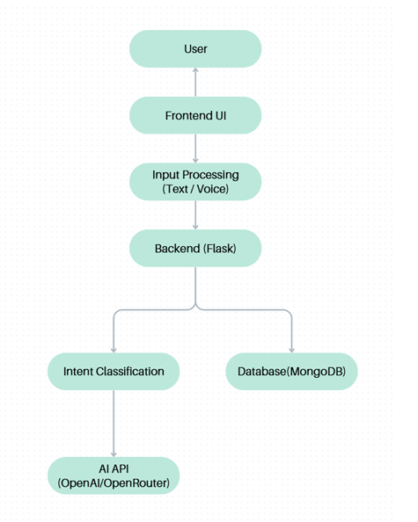
- Provides user interface for:
  - Book browsing
  - Search functionality
  - Chatbot interaction (text & voice)
- Communicates with backend via REST APIs
2. Backend
- Built using Flask
- Handles:
  - API requests and responses
  - Business logic
  - Communication with AI module
- Acts as a bridge between frontend and database
3. Database
- Implemented using MongoDB
- Stores:
  - Book details (ISBN, title, author, price)
  - User data
  - Interaction logs

4. AI & Speech Layer
- NLP for query understanding
- Speech-to-Text (STT) for voice input
- Text-to-Speech (TTS) for voice output

2.2 Process Flow
The system follows a structured process flow to handle user queries efficiently:
- User opens the web application
- User enters query (text or voice)
- If voice input:
  - Converted to text using Speech-to-Text
- Query is sent to backend server via API
- Backend forwards query to AI module
- NLP processes the query:
  - Intent detection
  - Entity recognition
- AI generates response
- Backend sends response to frontend
- If voice enabled:
  - Text converted to speech
- User receives response
2.3 Information Flow
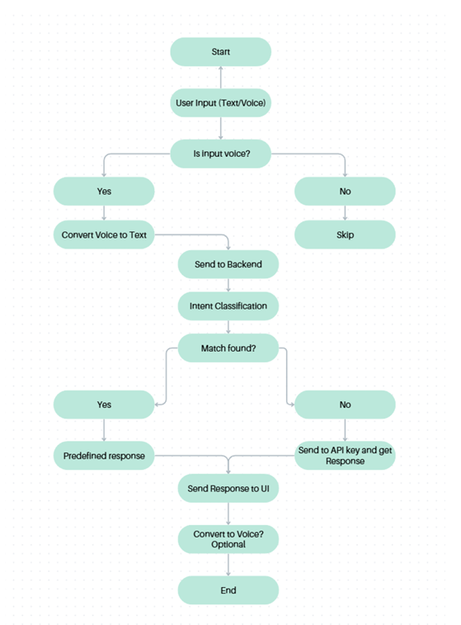
The information flow describes how data moves within the system:
- User → Frontend
  - Input query (text/voice)
- Frontend → Backend
  - Sends API request with user query
- Backend → AI Module
  - Passes query for processing
- AI Module → Backend
  - Returns processed response
- Backend → Database
  - Fetches book data or stores logs
- Backend → Frontend
  - Sends final response
- Frontend → User
  - Displays or speaks response
2.4 Components Design
The system is composed of the following components:
1. User Interface Component
- Handles user interaction
- Displays chatbot and bookstore UI
2. API Gateway (Flask Server)
- Receives and processes requests
- Routes requests to appropriate modules
3. AI Processing Component
- NLP engine for understanding queries
- Generates intelligent responses
4. Database Component
- Stores structured and unstructured data
- Provides fast retrieval
5. Speech Processing Component
- Converts voice ↔ text
- Enhances user interaction
2.5 Key Design Considerations
The system is designed keeping the following factors in mind:
1. Scalability
- System can handle multiple users simultaneously
- Can be deployed on cloud for scaling
2. Performance
- Fast response time using lightweight backend
- Efficient database queries
3. Reliability
- Ensures consistent system behavior
- Error handling mechanisms included
4. Usability
- Simple and intuitive UI
- Supports both voice and text interaction
5. Security
- Secure API communication
- Data protection and validation
6. Maintainability
- Modular architecture
- Easy to update components
2.6 API Catalogue
The system uses REST APIs for communication between frontend and backend.
1. Chat API
- Endpoint: /api/chat
- Method: POST
- Description: Handles user queries
- Input: User query (text)
- Output: AI-generated response
2. Voice Processing API
- Endpoint: /api/voice
- Method: POST
- Description: Processes voice input
- Input: Audio file
- Output: Text + Response
3. Book Search API
- Endpoint: /api/books/search
- Method: GET
- Description: Search books by title/author
- Input: Query parameters
- Output: List of books
4. Book Details API
- Endpoint: /api/books/{id}
- Method: GET
- Description: Fetch book details
- Output: Book information
5. User Interaction API
- Endpoint: /api/logs
- Method: POST
- Description: Stores user interactions
- Output: Success status
3. Data Design
3.1 Data Model
The system uses a NoSQL database (MongoDB) to store data in a flexible, JSON-like document format. This allows easy scalability and dynamic schema updates.
Main Collections:
- Books: Stores book details such as ISBN, title, author, genre, price, publication year, description, and stock availability.
- Users: Contains user information including user ID, name, email, encrypted password, and preferences.
- Chat Logs: Stores interactions between users and the AI chatbot, including query, response, and timestamp.
- Orders/Cart (Optional): Stores purchase details such as order ID, user ID, book IDs, quantity, total price, and order status.
3.2 Data Access Mechanism
Data is accessed through a structured API-based approach.
- API-Based Access: Frontend communicates with backend using REST APIs, and backend interacts with MongoDB.
- CRUD Operations:
  - Create → Add data
  - Read → Retrieve data
  - Update → Modify data
  - Delete → Remove unnecessary data
- Query Optimization: Indexing is applied on frequently searched fields like title and author for faster performance.
- Data Validation: Backend validates input data to ensure accuracy and security.
3.3 Data Retention Policies
The system manages data efficiently while ensuring privacy.
- Chat Logs: Stored for a limited period to improve AI performance
- User Data: Stored while the account is active and can be deleted on request
- Book Data: Stored permanently unless modified by admin
- Backups: Regular backups are maintained to prevent data loss
3.4 Data Migration
The system supports smooth data migration and scalability.
- Initial Setup: Book data is imported from CSV/JSON files into MongoDB
- Schema Flexibility: New fields can be added without affecting existing data
- Migration Strategy: Data can be moved to cloud platforms like MongoDB Atlas
- Backup & Restore: Data is backed up before migration and can be restored if needed
4. Interfaces
The system utilizes well-defined interfaces to ensure seamless communication between the frontend, backend, database, and AI modules. These interfaces enable efficient data exchange, modularity, and scalability of the system.

4.1 User Interface
The User Interface is developed using React and serves as the primary interaction point for users. It enables users to perform actions such as chatting with the system, searching for information, and providing voice input.

4.2 API Interface
The system employs RESTful APIs to facilitate communication between the frontend and backend. These APIs use standard HTTP methods and exchange data in JSON format, ensuring stateless and efficient communication.

4.3 Backend–Database Interface
The backend interacts with the MongoDB database to manage data operations. It performs CRUD (Create, Read, Update, Delete) operations and handles data retrieval efficiently.

4.4 AI Module Interface
The AI module processes user queries using Natural Language Processing (NLP) techniques and generates context-aware and relevant responses.

4.5 Speech Interface
The speech interface enables voice-based interaction by converting speech to text and text to speech, enhancing user accessibility and experience.

4.6 External Interfaces
The system integrates with external services such as AI APIs, speech processing APIs, and cloud-based databases to extend its functionality and scalability.

4.7 System Flow
The overall system workflow can be represented as:
- User ⇄ Frontend ⇄ Backend ⇄ (AI Module / Database / Speech Services)

5. State and Session Management
State and session management ensure smooth user interactions and a consistent experience across the system.

5.1 State Management
State represents the current status of the application.
- Frontend: Managed using React (useState, useContext) to store user inputs, chatbot responses, and UI states (loading, errors).
- Backend: Designed as stateless, where each request is processed independently, improving scalability and performance.
5.2 Session Management
Session management tracks user activity across multiple requests.
- Each user is assigned a unique Session ID
- Sessions can be stored using cookies, server-side storage, or MongoDB
5.3 Chat Session Handling
- Conversations are linked to a session/user ID
- Chat history is stored in the database
- Enables context-aware responses
5.4 Stateless vs Stateful
- Stateless: Independent API requests, no server memory usage
- Stateful: Chat history stored for continuity
5.5 Security & Timeout
- Secure Session IDs and HTTP-only cookies
- Data validation on each request
- Sessions expire after inactivity (15–30 minutes)

6. Caching
Caching is used to improve system performance by storing frequently accessed data temporarily, reducing database load and response time.
Caching Strategy:
- Frequently accessed data such as:
  - Book details
  - Search results
  - Common chatbot responses
are cached
Types of Caching Used:
1. Client-Side Caching
- Browser stores static data (HTML, CSS, JS)
- Reduces repeated server requests
2. Server-Side Caching
- Backend caches frequently requested data
- Reduces database queries
3. API Response Caching
- Frequently used API responses stored temporarily
- Improves response time

7. Non-Functional Requirements
Non-functional requirements define how the system performs rather than what it does.

7.1 Security Aspects
Security is an important consideration in the system design.
Measures Implemented:
- Authentication & Authorization
  - Secure user login system
- Data Encryption
  - Passwords stored in encrypted format
- Secure API Communication
  - Use of HTTPS protocol
- Input Validation
  - Prevents injection attacks
- Session Security
  - Secure session IDs and timeout mechanism
- Data Privacy
  - User data handled securely

7.2 Performance Aspects
The system is designed to deliver high performance and responsiveness.
Key Performance Factors:
- Fast Response Time
  - Optimized backend APIs
- Efficient Database Queries
  - Use of indexing in MongoDB
- Scalability
  - System can handle multiple users simultaneously
- Load Handling
  - Can manage increased traffic
- Optimized Frontend
  - Lightweight UI for faster loading

8. References

[1] R. Santana et al., "A Chatbot to Support Basic Students Questions," LALA, 2021.

[2] O. Zahour et al., "Chatbot E-Orientation for Educational Guidance," Int. Journal, 2020.

[3] J. Cranmore et al., "Advising High School Students for Fine Arts Programs," J. School Counseling, 2019.

[4] P. Alonso, "Efficient Intent Classification," Doctoral Dissertation, 2020.

[5] A. H. Hefny et al., "Intent Classification for Conversational Assistant," IEEE ICCES, 2020.

[6] J. Schuurmans and F. Frasincar, "Intent Classification for Dialogue," IEEE Intelligent Systems, 2020.

[7] S. Pérez-Vera et al., "Intent Classification using ML," Springer, 2017.

[8] S. Hamad and T. Yeferny, "Chatbot for Information Security," arXiv, 2020.

[9] N. V. Shinde et al., "Healthcare Chatbot using AI," IEEE ICOEI, 2021.

[10] M. Sarosa et al., "Social Media Chatbot for English Learning," IOP Conf., 2020.

[11] H. Yang et al., "AI Chatbot as English Conversation Partner," ReCALL, 2022.

[12] E. Vázquez-Cano et al., "Chatbot for Learning Punctuation," Int. Journal EdTech, 2021.

[13] H.-L. Chen et al., "Chatbot for Learning Chinese," J. Educ. Computing Research, 2020.

[14] J. Yin et al., "Chatbot-Based Learning and Motivation," J. Educ. Computing Research, 2021.

[15] J.-J. Tseng, "TPACK-SLA Interface," Computer Assisted Language Learning, 2018.

[16] L. K. Fryer et al., "Chatbot Learning Partners," Computers in Human Behavior, 2019.

[17] American School Counselor Association, "School Counselor Roles & Ratios," 2022.

[18] M. Oripova, "Academic Advising and Student Commitment," SSRN.

[19] N. Abbas et al., "Chatbots in Education," Int. Journal of Lifelong Education, 2022.

[20] A. P. Lin et al., "VR Chatbot Counseling System," Applied Sciences, 2021.

[21] S. Kannan et al., "Text Mining Preprocessing Techniques," IJCSCN, 2014.

[22] Q. Liu et al., "TF-IDF Feature Extraction," IEEE, 2018.

[23] G. Zhao et al., "TF-IDF Based Extraction," ICME, 2018.

[24] W. M. Shaban et al., "Naïve Bayes Classification," Pattern Recognition, 2021.

[25] IBM Cloud Education, "Random Forest," 2020.

[26] K. Lemons, "Naïve Bayes vs Random Forest," IJURCA, 2020.

